What is DevOps?
DevOps is a transformative approach that combines development (Dev) and operations (Ops) to enhance collaboration and productivity within organizations. It aims to break down traditional silos between software development and IT operations, fostering a culture of continuous integration, continuous delivery (CI/CD), and continuous feedback. By automating workflows and leveraging tools like Jenkins, Docker, and Kubernetes, DevOps facilitates faster and more reliable software releases. This methodology not only improves the efficiency and speed of software delivery but also ensures higher quality and stability of applications. Ultimately, DevOps drives innovation and agility, enabling businesses to respond swiftly to market changes and customer needs.
======================================================
What is LINUX,
Every devops tool we have to use in Linux only,
- Linux is an operating system,
- Linux is an open-source operating system that is a key component of Devops
- Linux is free of cast to download
- Linux is very stable & it can run performance
- Linux is the best choice for hosting web application data bases and programs to run the application,
- Linux has it own scripting language which is “bash”

Linux is also having powerful networking tools [commands],
- Ip configures interfaces, routes and move
- If config what’s my ip address
- Iw setup wifi from the command line
- Ping are these computers even connected
- Ngrep grep for your network
- Arp see your arp table
- Ethtool understand your ethernet connections secure network connections

File structure Linux,
- In the Linux everything is a file,
- The file structure linux starts with “/” [/]

Very very imp this file structure,
- /bin
- /etc
- /tmp
- /opt

Boot directory,
- To check the system hardware
- To check the hardware eguipmet
Dev directory,
- Device related information
- Consists of hard disks
- Consists of hard disk partitions
- Here drives names like [sda1,sda2,sda3]

/Etc directory,
- It consists of different types of configuration files

/opt directory,
- Consists of third party apps like, fire fox chrome etc we can see files stores in this /opt
System directory,
- System related information
- To check the processor ram,
- To check run how much consumer & hard disk

====================================================
Bin
- In bin is consists of basic commands like [ls,cp,copyind,cd ect ….]

- Ls command selectls command right click open in terminal
Sudo command supervisor do,
- Rm remove
- Just file view cat command
- Sbin directory to create new user,
- Cd change director

Root director
- System modification commands whose executes superusers linux
- System modification commands whose executes administrator windows.
1, what are different os have you familiar with and worked on?
Some common operating systems developers and IT professionals work with include:
- Linux (various distributions like Ubuntu, CentOS, Red Hat, Debian)
- Windows
- macOS
- Unix (AIX, Solaris)

2, what is kernel?
The kernel is the core part of an operating system that manages hardware resources such as CPU, memory, and peripheral devices. It acts as an intermediary between applications and the hardware, ensuring proper communication and resource management.
3, which Linux version you used in your project?
I have worked with several Linux distributions, including Ubuntu, CentOS, and Red Hat Enterprise Linux (RHEL). The version depends on the requirements of the project and the environment (e.g., development, testing, production).
4, why we used linux os rather than windows and any other?
Linux is preferred for many server-side applications due to its stability, security, flexibility, and open-source nature. It offers better performance in multi-user environments, lower overhead, and is highly customizable. It also supports a wide range of development tools and technologies, especially in DevOps environments.
======================================================
======================================================
======================================================
======================================================
======================================================
======================================================
======================================================
======================================================
======================================================
======================================================
======================================================
======================================================
Basic Linux Questions,
1. What is Linux?
Linux is an open-source, Unix-like operating system kernel created by Linus Torvalds. It is widely used in servers, desktops, and various embedded systems.
2. What are the basic components of a Linux system?
The basic components include the kernel, system libraries, system utilities, and application programs.
3. How do you check the current kernel version?
Use the command: uname -r
4. How do you list files in a directory?
Use the ls command.
5. What is the command to change file permissions?
Use the chmod command.
6. How do you view the contents of a file?
Use the cat, more, less, or tail commands.
7. What is the command to copy files or directories?
Use the cp command.
8. How do you move or rename a file?
Use the mv command.
9. How do you create a new directory?
Use the mkdir command.
10. What is the command to delete a file?
Use the rm command.

Intermediate Linux Questions,
1. How do you monitor system processes?
Use the top or htop command.
2. What command would you use to find the IP address of your system?
Use the ifconfig or ip addr command.
3. How do you create a user in Linux?
Use the useradd command.
4. How do you change the password of a user?
Use the passwd command.
5. What is SSH and how is it used?
SSH (Secure Shell) is a protocol used to securely connect to a remote server. Use ssh username@hostname.
6. How do you check disk usage in Linux?
Use the df and du commands.
7. How do you view running processes in Linux?
Use the ps command.
8. How do you kill a process?
Use the kill command followed by the process ID (PID).
9. What is the difference between su and sudo?
su switches the current user to another user, while sudo allows permitted users to execute commands as the superuser.
10. How do you change the ownership of a file?
Use the chown command.

Advanced Linux Questions,
1. What is the Linux kernel?
The kernel is the core part of the Linux operating system that manages system resources and hardware.
2. How do you compile a new kernel?
Download the kernel source, configure it using make menuconfig, then compile and install using make and make install.
3. What are runlevels in Linux?
Runlevels are different modes of operation in Linux, each defining a different state of the machine, such as shutdown, single-user mode, or multi-user mode.
4. How do you change the runlevel?
Use the init or systemctl command.
5. What is SELinux?
SELinux (Security-Enhanced Linux) is a security module that provides a mechanism for supporting access control security policies.

6. How do you enable and disable a service?
Use the systemctl enable and systemctl disable commands.
7. What is a swap space?
Swap space is a portion of the hard disk used as virtual memory to extend the physical memory of the system. Refer to How to change Swappiness for more details.
8. How do you create a swap file?
Use dd to create the file, mkswap to set up the swap area, and swapon to enable it.
9. How do you tune the system performance?
Adjust kernel parameters using sysctl and manage system resources using tools like top, htop, and iotop.
10. What are iptables?
Iptables is a command-line firewall utility that uses policy chains to allow or block traffic.
=====================================================
=====================================================
=====================================================
=====================================================
=====================================================
=====================================================
=====================================================
=====================================================

What is git, GitHub and interview questions,

What is Git?
Git is a popular version control system. It was created by Linus Torvalds in 2005, and has been maintained by Junio Hamano since then.
It is used for:
- Tracking code changes
- Tracking who made changes
- Coding collaboration

What does Git do?
- Manage projects with Repositories
- Clone a project to work on a local copy
- Control and track changes with Staging and Committing
- Branch and Merge to allow for work on different parts and versions of a project
- Pull the latest version of the project to a local copy
- Push local updates to the main project

Working with Git
- Initialize Git on a folder, making it a Repository
- Git now creates a hidden folder to keep track of changes in that folder
- When a file is changed, added or deleted, it is considered modified
- You select the modified files you want to Stage
- The Staged files are Committed, which prompts Git to store a permanent snapshot of the files
- Git allows you to see the full history of every commit.
- You can revert back to any previous commit.
- Git does not store a separate copy of every file in every commit, but keeps track of changes made in each commit!

Why Git?
- Over 70% of developers use Git!
- Developers can work together from anywhere in the world.
- Developers can see the full history of the project.
- Developers can revert to earlier versions of a project.

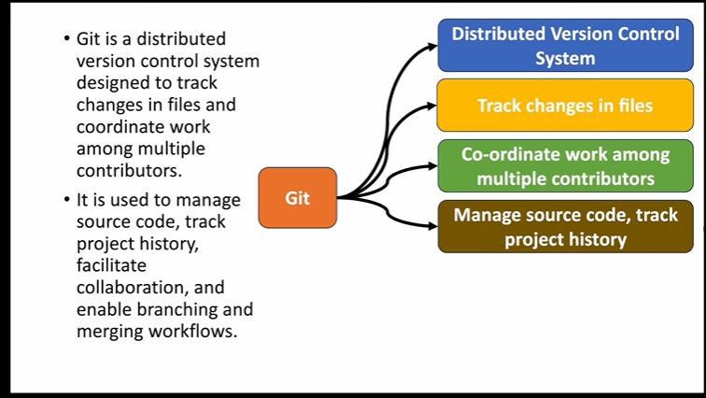
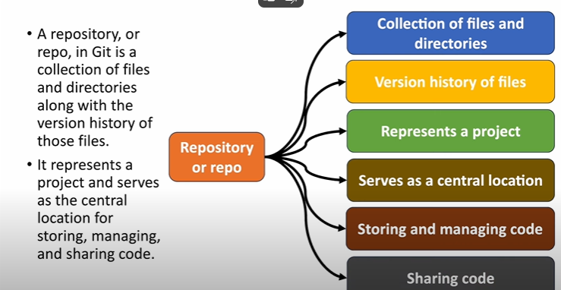

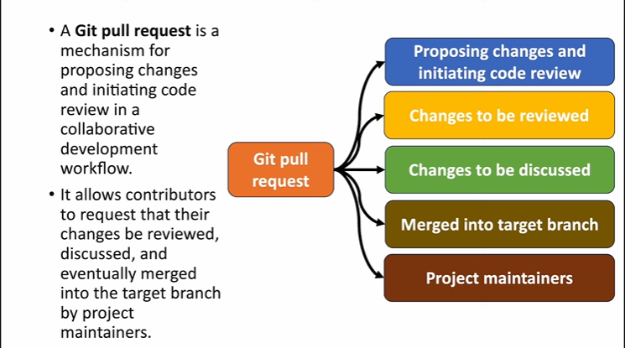

What is GitHub?
- Git is not the same as GitHub.
- GitHub makes tools that use Git.
- GitHub is the largest host of source code in the world, and has been owned by Microsoft since 2018.
- In this tutorial, we will focus on using Git with GitHub.
(or)
Git is a distributed version control system (VCS) that allows developers to track and manage changes to a project's codebase. It helps coordinate the work of multiple developers, enabling them to collaborate efficiently on software development projects. Git is widely used in both individual and team-based software projects, and it provides powerful features for managing source code, tracking revisions, and handling branches.
Git is a version control system used to track changes in source code during software development. It allows developers to collaborate efficiently and manage the history of code changes.

GitHub is a cloud-based platform that uses Git to provide a space for version control and collaboration. It also offers features like issue tracking, code review, and CI/CD integrations.
Key features of Git include:
Version control: Git tracks every change made to the code, allowing you to revisit and restore previous versions.
Branching: Git allows you to create branches to work on new features, bug fixes, or experiments independently of the main project.
Distributed: Every developer has a full copy of the repository, which allows them to work offline and synchronize changes with others later.
Collaboration: Multiple developers can work on the same project simultaneously, merging their changes without conflicts.

Common Git Commands:
Here’s an overview of some of the most commonly used Git commands:

1. git init
- Initializes a new Git repository in the current directory. This command sets up all the necessary files and configuration to start tracking changes.
git init

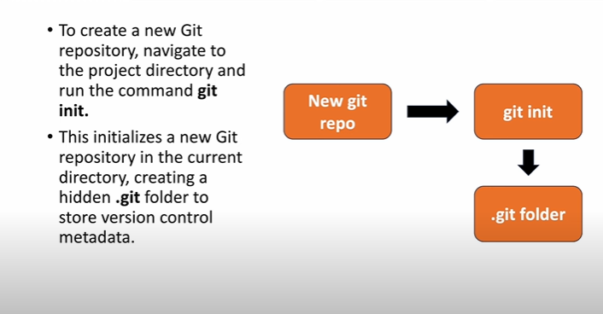

2. git clone
- Clones an existing repository from a remote server (like GitHub) to your local machine. This command creates a copy of the entire repository, including all branches and commit history.
- git clone <repository_url>

3. git status
- Shows the current state of the working directory and staging area. It tells you which files are modified, added, or deleted, and whether they have been staged for commit.
- git status

4. git add [working to staging]
- Adds changes in the working directory to the staging area. It prepares the files for committing.
- git add <file> # Add a specific file
- git add . # Add all changed files

5. git commit [ staging to local]
- Commits the changes in the staging area to the local repository. Each commit is accompanied by a commit message describing the changes.
- git commit -m "Commit message here"
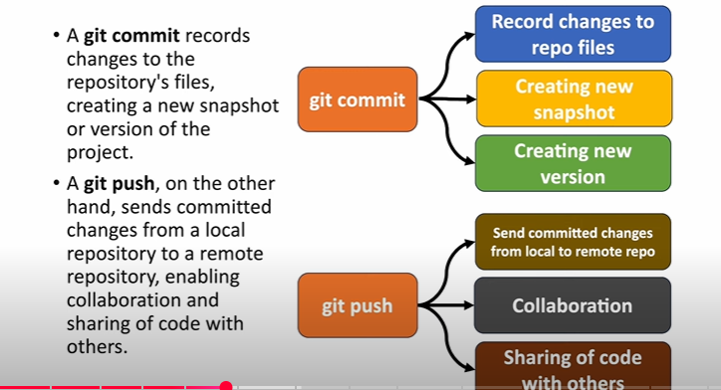

6. git push [local to remoto]
- Pushes local commits to a remote repository, like GitHub. This command is used to share your changes with others.
- git push origin <branch-name>

git add <file>
git add .<select all files>
git commit -m "Your commit message"
origin check == git remote -v
origin remove command ==== git remote remove origin
git add origin==== git remote add origin <repository-url git hub>

7. git pull
- Fetches changes from a remote repository and merges them into your local branch. It’s used to sync your local repository with the remote repository.
- git pull origin <branch-name>

8. git fetch
- Downloads the latest changes from the remote repository without merging them into your local branch. This command lets you review changes before integrating them.
- git fetch origin

9. git branch
- Lists, creates, or deletes branches. A branch is a separate line of development.
- git branch # List all branches
- git branch <branch-name> # Create a new branch
- git branch -d <branch-name> # Delete a branch

10. git checkout
- Switches between branches or restores files in the working directory.
- git checkout <branch-name> # Switch to a different branch
- git checkout -- <file> # Discard changes in a specific file

11. git merge
- Combines changes from one branch into another. Typically used to merge feature branches into the main branch (e.g., master or main).
- git merge <branch-name>

12. git log
- Displays the commit history for the current branch. You can use various flags to format or filter the output.
Use git log for the full commit history. Show full commit history
Use git log -n <number> to limit the number of commits.

Use git log --oneline for a more concise view.

13. git diff
- Shows the differences between the working directory and the staging area or between two commits.
- git diff # Show changes not yet staged
- git diff --cached # Show changes staged for commit

14. git reset
- Resets the current branch to a specific commit. You can use it to undo changes, remove commits, or unstage files.
- git reset <commit-id> # Reset to a specific commit
- git reset --hard <commit-id> # Reset and discard all changes (dangerous)

15. git rm
- Removes files from the working directory and stages them for deletion in the next commit.
- git rm <file> # Remove a specific file
- git rm -r <directory> # Remove a directory and its contents

16. git stash
- Temporarily saves changes that are not ready to commit. This allows you to switch branches without losing uncommitted work.
- git stash # Save uncommitted changes
- git stash pop # Retrieve saved changes

17. git tag
- Creates tags to mark specific points in the repository history (typically used for releases).
- git tag <tag-name> # Create a new tag
- git tag -d <tag-name> # Delete a tag
- git push origin <tag-name> # Push a tag to the remote repository

Additional Concepts
- Repository: A Git repository is where all your project files and their history are stored. It can be local (on your computer) or remote (on a server like GitHub).
- Commit: A commit is a snapshot of your changes at a certain point in time. Each commit has a unique identifier and contains the changes made, the author, and a commit message.
- Branch: A branch is a separate line of development that allows you to work on different features or fixes independently. You can merge branches to integrate changes.
- Clone: Cloning a repository copies all the files, branches, and history of the repository from a remote source to your local machine.
- Merge: Merging combines the changes from two branches into one. Conflicts may arise if the same part of the file was changed in both branches, and you must resolve these conflicts manually.

What is git reflog?
The git reflog command in Git is used to view the history of changes to the references in a repository, such as HEAD or branches. It provides a record of where your references (like HEAD) have pointed over time, making it a powerful tool to recover lost commits, track changes, and navigate through your project's history.

Key Points about git reflog:
- Reflog stands for reference log. It keeps a log of all changes to the tip of branches and other references (like HEAD).
- Every time you make a change (such as committing, checking out a branch, resetting, or rebasing), Git updates the reflog for the affected reference. This means you can track where HEAD or any branch reference has been, even if you’ve moved it around.

Why is git reflog Useful?
- Recovering Lost Commits: If you've accidentally reset, rebased, or made a change that lost commits, git reflog allows you to trace back to previous states and recover those lost commits.
- Tracking Reference Changes: It helps track movements of references like HEAD, branches, and other references. This is especially useful when navigating through a messy commit history.
- Undoing Mistakes: If you've made an incorrect reset or commit, git reflog lets you go back to the previous states before the mistake.
- Dealing with Detached HEAD: If you find yourself in a detached HEAD state (e.g., after checking out an older commit), git reflog shows you the history of HEAD so you can return to a branch.

Basic Usage of git reflog:

1. View the Reflog for HEAD:
To see the history of changes to HEAD (the current working reference):
git reflog
Example output:
sql
1a2b3c4 HEAD@{0}: commit: Fixed bug in login form
5d6e7f8 HEAD@{1}: commit: Added user authentication
9a0b1c2 HEAD@{2}: checkout: moving from feature-branch to main
3d4e5f6 HEAD@{3}: commit: Initial commit
- Each entry in the reflog has a reference like HEAD@{0}, HEAD@{1}, etc., indicating the state at that point in time.
- HEAD@{0} is the most recent change, HEAD@{1} is the one before that, and so on.

2. View the Reflog for a Specific Branch:
You can also view the reflog for specific branches, not just HEAD:
git reflog <branch-name>
Example:
git reflog main
This will show the history of main branch references.

3. Checkout a Previous Commit:
You can use the reflog to return to a previous state by checking out an earlier commit (using its reflog entry):
git checkout HEAD@{1}
This command will move your working directory to the state it was in at HEAD@{1}. You can also use git reset for similar purposes.

4. Reset to a Previous State Using Reflog:
If you want to undo changes and reset your branch to a previous state:
git reset --hard HEAD@{2}
This will reset your branch to the state it was in at HEAD@{2}.

Common Scenarios for Using git reflog:
- Recovering a Lost Commit: If you've accidentally reset or lost a commit, git reflog can help you find the commit hash and recover it. For example, after a git reset --hard that removes commits, you can use:

git reflog
git checkout HEAD@{1} # Or git reset --hard HEAD@{1}
- Undoing a Checkout or Branch Switch: If you checked out the wrong branch or commit, you can use git reflog to find the previous position of HEAD and return to it.
- Recovering from a Detached HEAD: If you're working in a detached HEAD state (where HEAD isn't pointing to a branch), git reflog can show you where HEAD was last attached to a branch, and you can switch back to that branch:
git reflog
git checkout <branch-name>

Example Use Cases:
- Recover a commit lost due to a reset:
git reflog # Find the commit hash of the lost commit
git reset --hard HEAD@{1} # Reset to the commit you want to recover
- Undo a checkout or branch switch:
git reflog # Find the previous HEAD reference
git checkout HEAD@{2} # Checkout the previous commit

Important Notes:
- Reflog is Local: The reflog is stored locally, and it is not pushed to remote repositories. This means that once you push changes or if the local repository is discarded, the reflog entries are lost.
- Expire Over Time: By default, Git keeps reflog entries for 90 days (or 30 days for expired references), but you can configure the expiration period if needed.

Summary:
- git reflog provides a history of all changes to Git references, such as HEAD.
- It's useful for recovering lost commits, undoing mistakes, and tracking changes to references.
- You can view, reset, or checkout previous states using the reflog.

What is git cherry-pick and when would you use it?
Answer:
git cherry-pick is a Git command that allows you to apply a specific commit from one branch onto another. It essentially lets you pick individual commits and integrate them into your current branch without merging the entire branch.
You would use git cherry-pick in situations where:
- You need to apply specific bug fixes or features from one branch to another, without merging all changes.
- For example, if you're working on the main branch and you want a bug fix from a feature branch, but you don't want to merge the entire branch, you can cherry-pick the commit that includes the fix.
- It can also be useful when you need to bring in changes from a hotfix branch into a stable branch.

Example Scenario:
Imagine you're working on a development branch and a critical bug is fixed on a feature branch. Instead of merging the entire feature branch into development, which may introduce unnecessary changes, you can cherry-pick just the commit with the bug fix using:
git cherry-pick <commit-hash>
While git cherry-pick is useful, it can sometimes lead to merge conflicts if the changes don't apply cleanly, and you may need to resolve those conflicts manually. Also, it can create duplicate commits in the history if the same commits are later merged or rebased, so it's important to use it selectively.

Key Points to Emphasize in a One-Year Experience Answer:
- Brief but clear explanation: You should be able to quickly explain what git cherry-pick does and why it's useful in simple terms.
- Practical usage example: Highlight real-world scenarios such as bug fixes or selective features to demonstrate practical knowledge.
- Mention conflict resolution: Briefly address that conflicts may arise and how Git handles them.
- Limitations: Recognizing the potential for duplicated commits or complex history when cherry-picking multiple times will show depth in understanding.

What is git reset and how does it work?
Answer: git reset is a command in Git used to undo changes by moving the HEAD to a specific commit. It can affect the commit history, staging area, and working directory based on the mode used.
- --soft: Resets HEAD to the specified commit but keeps changes staged. It's useful if you want to undo a commit but keep the changes ready for the next commit.
git reset --soft HEAD~1
- --mixed (default): Resets HEAD and unstages changes from the staging area, but the changes stay in your working directory. It's helpful when you want to unstage files but keep local modifications.
git reset --mixed HEAD~1
- --hard: Resets HEAD, unstages files, and discards changes in the working directory. This is a destructive option and should be used with caution.
git reset --hard HEAD~1

Use Case Example:
If you committed something by mistake and want to remove the commit but keep the changes for another commit, you'd use:
git reset --soft HEAD~1

Caution:
- Using --hard can permanently delete changes, so it should be used carefully.
- Avoid using git reset on shared/public branches as it rewrites commit history, which could cause issues for others.

Why We Use git stash and what is stash?
In Git, the git stash command is used to temporarily save changes in your working directory that you aren't ready to commit yet. This allows you to switch branches or perform other tasks without losing your current work. Once you’re ready to return to it, you can apply or pop the stashed changes back into your working directory.

Key Use Cases for git stash:
- Switching branches without committing: You’re working on a feature or bug fix, but need to switch branches to address an urgent task (e.g., a bug fix in the main branch). Instead of committing incomplete work, you can stash your changes, switch branches, and come back later to apply the stashed changes.
- Keep your working directory clean: When you want to temporarily clean your working directory to test something or pull in changes from a remote repository, but don’t want to commit incomplete or experimental changes.
- Apply or inspect changes later: If you're working on multiple tasks in parallel and want to save your progress but don’t want to commit it yet, stashing helps you store that work safely for future application.

How git stash Works:
- Stash Changes:
git stash
This saves both staged and unstaged changes (files you have modified but not committed) and resets your working directory to the state of the last commit. This lets you work in a clean environment.
- List Stashes: To see all the stashes you have saved:
git stash list
- Apply Stashed Changes: When you’re ready to resume your work, you can apply the latest stash:
git stash apply
This will reapply the changes but leave the stash in the list (you can apply it again later if needed).
- Pop Stashed Changes: To apply the changes and remove the stash from the list:
git stash pop
This is like applying the stash, but it will also remove it from the stash list after applying it.
- Stash Specific Files: If you only want to stash specific files, you can specify them:
git stash push <file1> <file2>
- Drop a Stash: To remove a specific stash from the list:
git stash drop stash@{0}

Example Scenario:
Let’s say you’re working on a feature, but need to quickly switch to the main branch to fix a critical bug.
- You’ve made some changes but aren’t ready to commit them.
- You can stash those changes:
git stash
- Now you can switch to the main branch to fix the bug:
git checkout main
- After fixing the bug and committing, you can return to your feature branch and reapply your stashed changes:
git checkout feature-branch
git stash pop

Advantages of git stash:
- Flexibility: You can switch contexts or work on other tasks without losing your progress.
- No need for committing incomplete work: You don’t have to commit work you’re not ready to push, which helps maintain a clean commit history.
- Works with untracked files: You can also stash untracked files with the -u or --include-untracked option.

Considerations:
- Stashed changes are not saved permanently, so it’s a temporary storage solution. Don’t rely on it for long-term storage.
- Be careful when switching branches after stashing, as applying the stash may cause conflicts if the branch has diverged significantly from the stashed changes.

What is git log --since?
git log --since is powerful for filtering and reviewing commit history within a specific date range, which is often used in cases like finding recent changes, analyzing a sprint, or reviewing work done after a particular date. You can also mention that this command can be combined with other options like --until, --oneline, and --pretty for more focused and readable results.

What is git reset?
git reset is a powerful and commonly used Git command that is primarily used to undo changes in your Git repository. It alters the state of the staging area (index) and/or working directory. It is often used to move the current branch's HEAD pointer to a previous commit, effectively "resetting" the branch to that state.
There are three main types of resets, depending on the flags used: soft, mixed, and hard.

Syntax:

git reset [<mode>] <commit>
- <commit> can be a commit hash, HEAD, or a relative reference like HEAD~1.
- <mode> specifies what part of the working directory and index to reset: soft, mixed, or hard.

Types of git reset:
- Soft Reset (--soft):
  - This option moves the HEAD pointer to a specified commit but leaves your working directory and staging area unchanged. This means all changes will be unstaged but still present in the working directory.
  - Use case: If you want to undo a commit but keep your changes for re-staging and committing again.
git reset --soft <commit>
Example:
git reset --soft HEAD~1
This will undo the last commit but leave the changes in your staging area.
- Mixed Reset (--mixed) (default):
  - This option moves the HEAD pointer to the specified commit and resets the staging area (index) to match the commit, but keeps the working directory unchanged. The changes will be left unstaged.
  - Use case: If you want to undo a commit and unstage the changes, but you still want to keep the changes in your working directory.
git reset --mixed <commit>
Example:
git reset HEAD~2
This will undo the last two commits, and the changes will be in your working directory but not staged for commit.
- Hard Reset (--hard):
  - This option moves the HEAD pointer to the specified commit, resets both the staging area and the working directory to match that commit. This means all changes will be discarded, both staged and unstaged.
  - Use case: If you want to completely discard changes and revert to a specific commit.
git reset --hard <commit>
Example:
git reset --hard HEAD~1
This will undo the last commit and discard any changes in the working directory and staging area, effectively resetting everything to the state of the previous commit.

Use Cases and Scenarios:
- Undoing the Last Commit (without losing changes):
git reset --soft HEAD~1
This allows you to undo the last commit but keep the changes staged for a new commit.
- Unstaring Changes: If you have staged changes but want to unstage them without losing them, you can use:
git reset HEAD <file>
- Completely Discarding Local Changes: If you've made a mistake and want to reset everything (including the working directory), you can use a hard reset:
git reset --hard HEAD~2
This will reset to the state of two commits ago, discarding all changes.

Key Points to Remember:
- git reset --soft: Moves HEAD, keeps changes in the staging area.
- git reset --mixed: Moves HEAD, unstages changes, keeps changes in the working directory (default).
- git reset --hard: Moves HEAD, resets staging and working directory, discards all changes.

Interview Answer Example:
"The git reset command is used to move the HEAD of a repository to a specific commit. It can be used to undo commits and adjust the staging area and working directory depending on the reset mode. There are three types of resets:
- --soft (moves HEAD, keeps changes staged),
- --mixed (moves HEAD, unstages changes but keeps them in the working directory),
- --hard (moves HEAD, discards changes in both the staging area and working directory).

In Git, the term 'revoke' typically refers to undoing or cancelling changes made by a commit. One way to do this is by using the git revert command. This command creates a new commit that undoes the changes from a previous commit. It's useful when you want to 'revoke' the effects of a commit without modifying the commit history."

Example:

git revert <commit-hash>
This will create a new commit that undoes the changes introduced by the specified commit, effectively "revoking" its impact on the project.
Top of Form
Get smarter responses, upload files and images, and more.

Already I done the push code to GitHub, but I am wrong commit id giving, now I edit that push commit id is it possible???
Yes, you can edit a commit that has already been pushed to GitHub. The process depends on whether the commit is the most recent or not.
- If it's the most recent commit:
Use git commit --amend to modify the commit message or content.
git commit --amend
- If it's not the most recent commit:
Use interactive rebase to edit earlier commits.
git rebase -i <commit-hash>^
Change pick to edit, then amend the commit with git commit --amend.
- Force-push the changes: After editing, push the changes with --force to update GitHub:
git push --force
Note: Force-pushing rewrites commit history, so use it carefully, especially in shared repositories.
This method allows you to fix the commit ID, but be cautious of the potential risks when force-pushing to a shared remote.

What is main and master??
In Git, main and master are the names of default branches in a repository. Historically, master was the default branch name when you initialized a new Git repository, but there has been a shift towards using main as the default branch name in many Git platforms and communities, including GitHub, GitLab, and others.
- master (Old Default Branch Name):
  - Historical Default: master was the default branch name in Git when a new repository was created.
  - Used for: It typically represents the "main" development branch in many projects.
  - Shift Away: There has been a growing movement to change the default branch name to main to be more inclusive.
- main (New Default Branch Name):
  - Current Default: Starting in 2020, GitHub and other platforms changed the default branch name from master to main for new repositories.
  - Used for: main is intended to be the primary branch where the stable code lives.

Why the Change from master to main?
The change from master to main is part of a broader effort to use more inclusive language in software development. The term master has historically been associated with oppressive and exclusionary contexts, and so main was adopted as a neutral alternative.
• master was historically the default branch name in Git.
• main is now the default branch name for new repositories in most modern platforms, including GitHub.
• Both represent the primary branch where the main development happens, but the shift to main reflects an effort to use more inclusive language in tech

Bottom of Form

A bout git GitHub and GitLab:
1, what is git GitHub and GitLab what is the difference between them ?
• Git is a version control system used to track changes in source code during software development. It allows developers to collaborate efficiently and manage the history of code changes.

• GitHub is a cloud-based platform that uses Git to provide a space for version control and collaboration. It also offers features like issue tracking, code review, and CI/CD integrations.

• GitLab is similar to GitHub but offers additional functionalities such as integrated CI/CD pipelines, issue tracking, and a more DevOps-centric environment. GitLab can be self-hosted, which provides more control over the environment.
2, what is merge and rebase?
• Merge: Combining changes from different branches in Git. When you merge, Git creates a new commit that combines the changes.
• Rebase: Moving or combining a sequence of commits to a new base commit. It rewrites commit history, making it linear and cleaner but potentially more complex than merging.
3, how do you revert a commit in git?
To revert a commit in Git, use the following command:
git revert <commit_hash>
This creates a new commit that undoes the changes introduced by the specified commit. The commit history remains intact.
4, explain the branching strategies have you used in your project?
Common branching strategies include:
- GitFlow: A well-defined model with separate branches for features, releases, and hotfixes.
- Feature Branching: Each feature has its own branch, and once complete, it is merged into the main branch.
- Trunk-Based Development: Developers work on a single main branch and commit frequently.

